**PG BC Capstone Project 1 Screenshots**

**-Abhishek Chatterjee**

1. **Adding Bank**

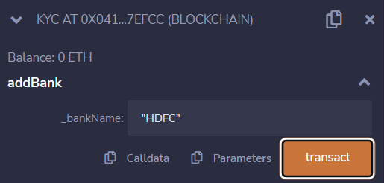

1. **Add new customer to bank**

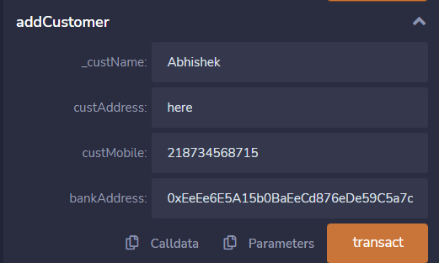

1. **Allow bank to do KYC of customers**

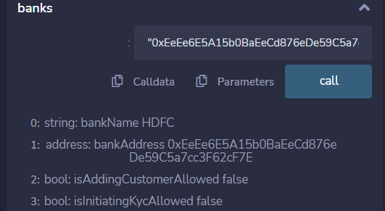

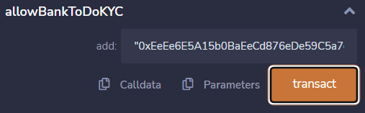

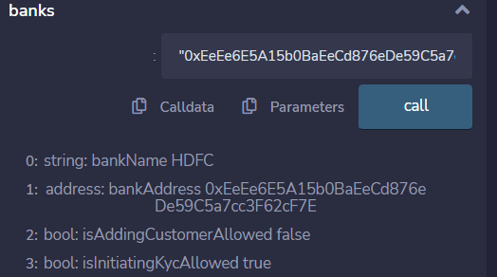

1. **Do KYC of customer**

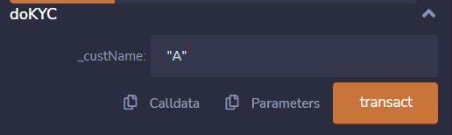

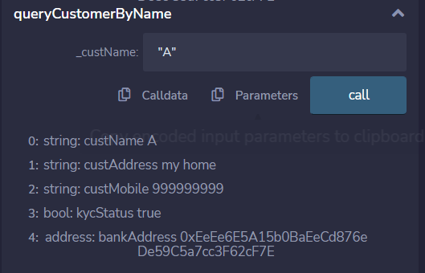

1. **Allow bank to add customer**

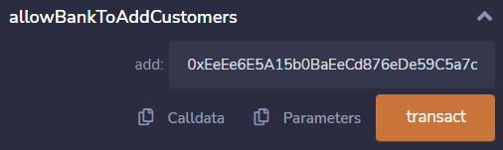

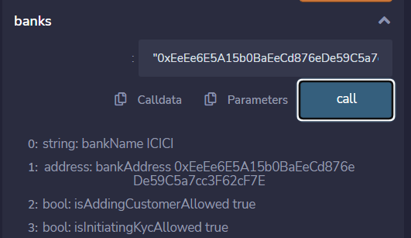

1. **Check KYC of customer**

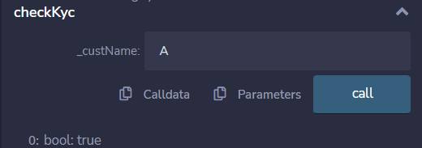

1. **Query customer details by name**

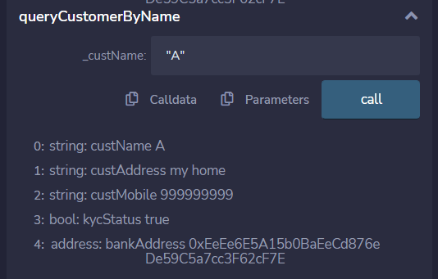

1. **Block bank to do KYC**

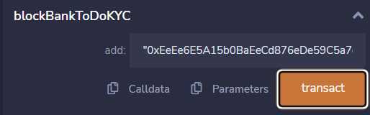

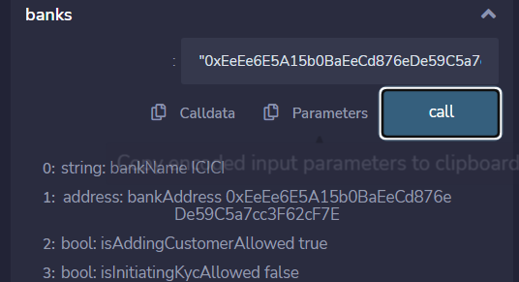

1. **Block bank to add customers**

